*Mohammad Amiri*

## *Portfolio Project: Final Report - Results and Learnings*

*5/8/2020*

**Project Title: Book**

**1. Introduction**

* Giving information about a book called “Breaking Through”. My goal is to introduce this book that I read before. This book was very interesting for me for this reason I wanted to introduce on a webpage. Also, the name of this webpage is the name of a book that I chose it.

**2. Design and Implementation**

* I used something that learns in the bootstrap class like the menu, accordion, modal, carousel, form, and cards.
* I think my project is not a big project. It has four menus such as **Home**, **About**, **Author**, and **Contact**. All of them designed on one page, not on a separate page.

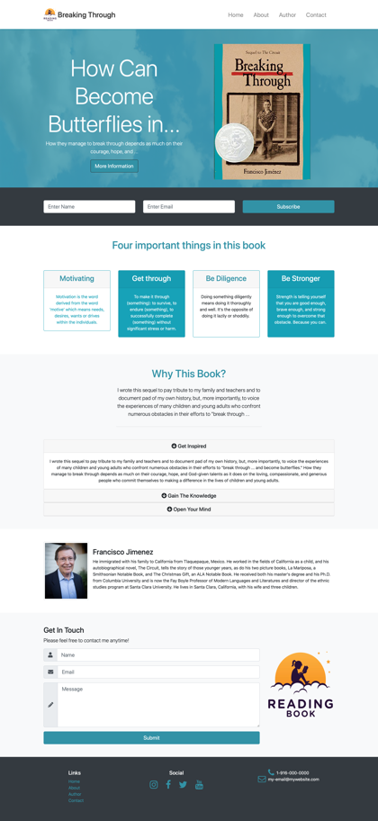

**3. Conclusions**

* Actually, it is simple project and all of my work is relevant bootstrap class. I did everything that I learned in bootstrap class and I didn’t have any innovation in the current project, but my next plan will be bigger and it has some innovation in the next portfolio.